Assignment 9

import java.sql.Driver;  
import java.sql.DriverManager;  
import java.sql.ResultSet;  
import java.sql.Statement;  
import java.sql.Connection;  
  
// Name: Apoorv Gupta  
// PRN: 21070126018  
// Batch: AIML-A1  
// Assignment 9: Write a Java program to insert, update and display records from the 'student_jdbc' table using JDBC.  
  
  
public class As9 {  
 public static void main(String[] args) {  
 // JDBC connection details  
 String url = "jdbc:mysql://localhost:3306/jdbcdemo"; // URL of the database  
 String username = "root"; // Username for the database  
 String password = "1234"; // Password for the database  
  
 try {  
 // Load the MySQL JDBC driver  
 Class.*forName*("com.mysql.jdbc.Driver");  
  
 // Create a connection to the database  
 Connection connection = DriverManager.*getConnection*(url, username, password);  
  
 // Create a statement to execute SQL queries  
 Statement statement = connection.createStatement();  
  
 // Insert a new record into the 'student_jdbc' table  
 int result = statement.executeUpdate("INSERT INTO student_jdbc (name, age, gender) VALUES ('Arjun', 19,'Male')");  
  
 // Update an existing record in the 'student_jdbc' table  
 int result2 = statement.executeUpdate("UPDATE student_jdbc SET name='Arjun Tyagi', age=20, gender='Male' WHERE id=3");  
  
 // Display the contents of the 'student_jdbc' table  
 display(statement);  
  
 // Close the database connection  
 connection.close();  
 }  
 catch (Exception e) {  
 // Print an error message if there is a problem with the JDBC connection  
 System.out.println("Where is your MySQL JDBC Driver?" + "\n" + e);  
 e.printStackTrace();  
 return;  
 }  
 }  
  
 public static void display(Statement statement){  
 try{  
 // Execute a SELECT query and get the result set  
 ResultSet resultSet = statement.executeQuery("SELECT * FROM student_jdbc");  
  
 // Iterate over the result set and display each record  
 while (resultSet.next()) {  
 System.*out*.println(resultSet.getInt(1) + " " + resultSet.getString(2) + " " + resultSet.getInt(3) + " " + resultSet.getString(4));  
 }  
 } catch (Exception e) {  
 // Print an error message if there is a problem with displaying the data  
 System.*out*.println("Error displaying data: " + e.getMessage());  
 }  
 }  
}

Output-

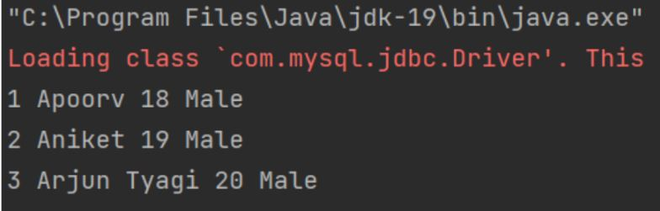

Github Link-

https://github.com/NachiketRopia2003/Java-Assignment/tree/main/Assignment%201